**Operation Analytics and Investigating Metric Spike**

**Advanced SQL**

**Project Description**

* In this project, we will perform operation analytics and investigative metric
* Operation Analytics is the analysis done for the complete end to end operations of a company. Which will help yammers company to find the areas which they have to improve.
* Investigating metric spike will help us to understand about any kind of dip happening in engagement

**Approach**

Using database of yammers users, SQL queries will be run to analyse. Operation Analytics and Investigating Metric

**Tech-Stack Used: MySQL Tutorial**

* MySQL is a widely used relational database management system.
* It is free and open-source.
* It is ideal for both small and large application.
* It is very easy to write query in MySQL
* MySQL uses a standard form of the well-known SQL data language.
* MySQL works very quickly and works well even with large data sets.

**Insights:**

**Case Study 1 (Job Data)**

1. **Number of jobs reviewed:**Amount of jobs reviewed over time.

Number of jobs reviewed per hour per day for November 2020 are as follow:

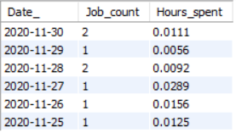

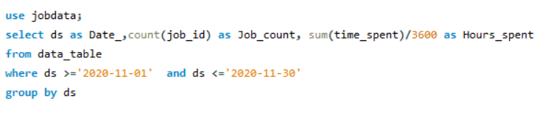Query used:

1. **Throughput:**It is the no. of events happening per second.

7 day rolling average of throughput as follow:

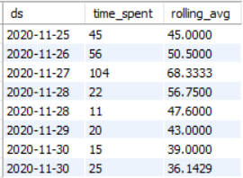

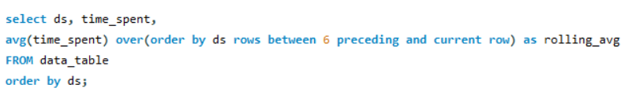Query used:

If a business is small then daily metric is preferred whereas if the business is large the prefer 7-day rolling is preferred. This analysis will help them to grow their business.

1. **Percentage share of each language:**Share of each language for different contents.  
   Percentage share of each language in the last 30 days is as follow:

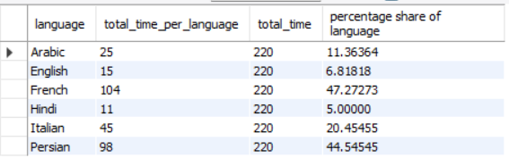

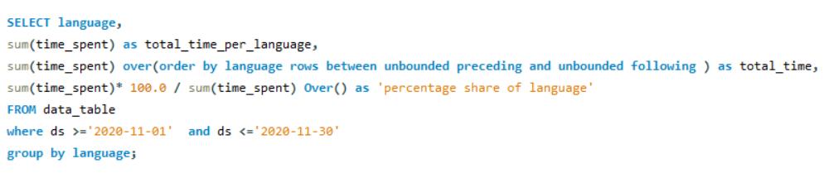Query used:

1. **Duplicate rows:**Rows that have the same value present in them.

As there is no two rows same in given data the result is null.

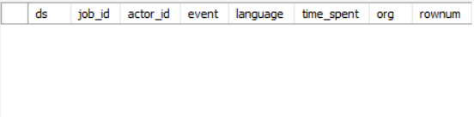

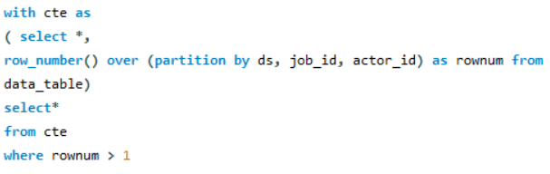Query used:

**Case Study 2 (Investigating metric spike)**

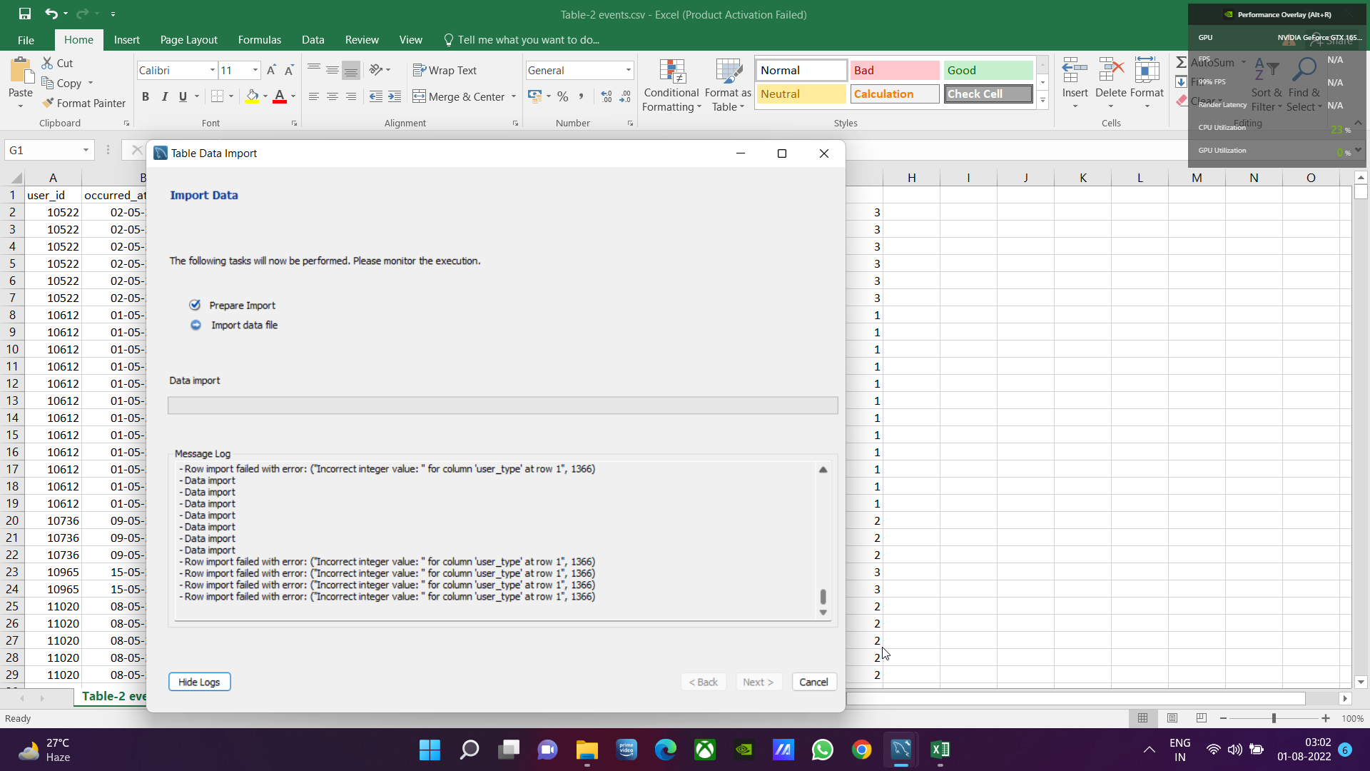**I tried for more than 3 hours to import tables correctly but it always showed same error so output can vary than actual one.**

1. **User Engagement:**To measure the activeness of a user. Measuring if the user finds quality in a product/service.

Weekly 2882 users engage with product



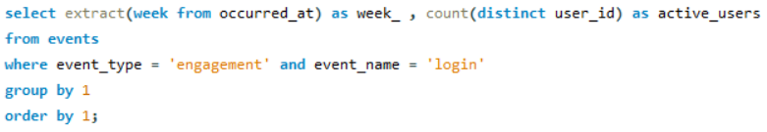Query used:

1. **User Growth:**Amount of users growing over time for a product.

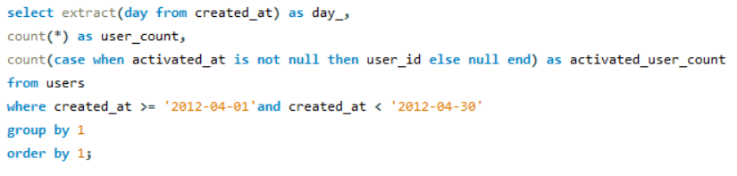Query used:

1. **Weekly Retention:**Users getting retained weekly after signing-up for a product.

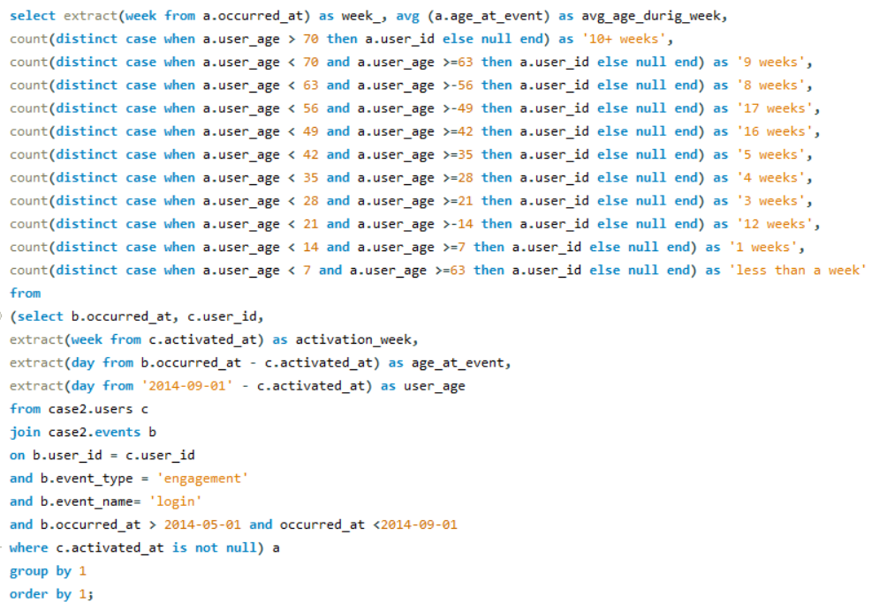Query used:

1. **Weekly Engagement:**To measure the activeness of a user. Measuring if the user finds quality in a product/service weekly.

Weekly engagement per device is as follow

Total weekly users: 2882

Computer: 1513

Phone: 1042

Tablet: 417



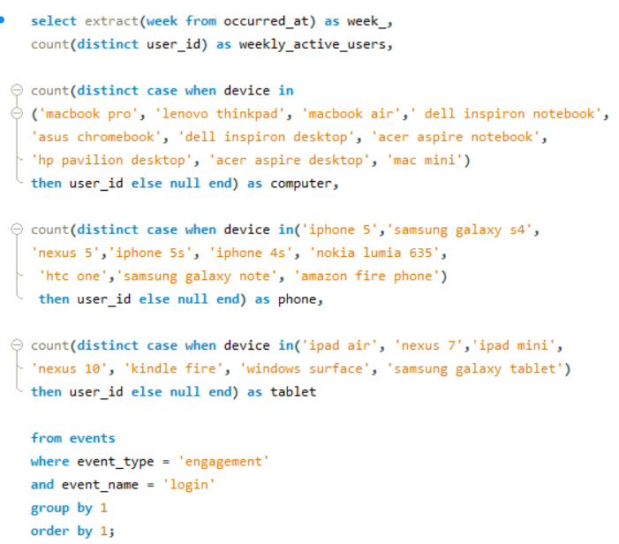Query used:

1. **Email Engagement:**Users engaging with the email service.

Email engagement metrics as follow:

For weekly sent count: 57267

Email opened count: 20459

Clicked links count: 9010

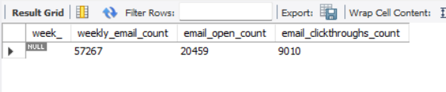

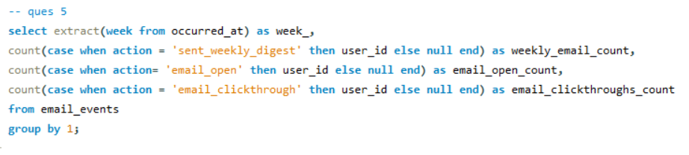Query used:

**Result:**

* In this project I have gain practical hands on knowledge advanced SQL queries to perform operation analytics and investigative metrics spike.
* This will further help me to perform data analysis in real world scenarios.